Aim: - Configuration of VLAN using Cisco Packet Tracer.

Software Required: -

Cisco Packet Tracer 8.2.0

Procedure and Outputs: -

Step 1: - Make Topology

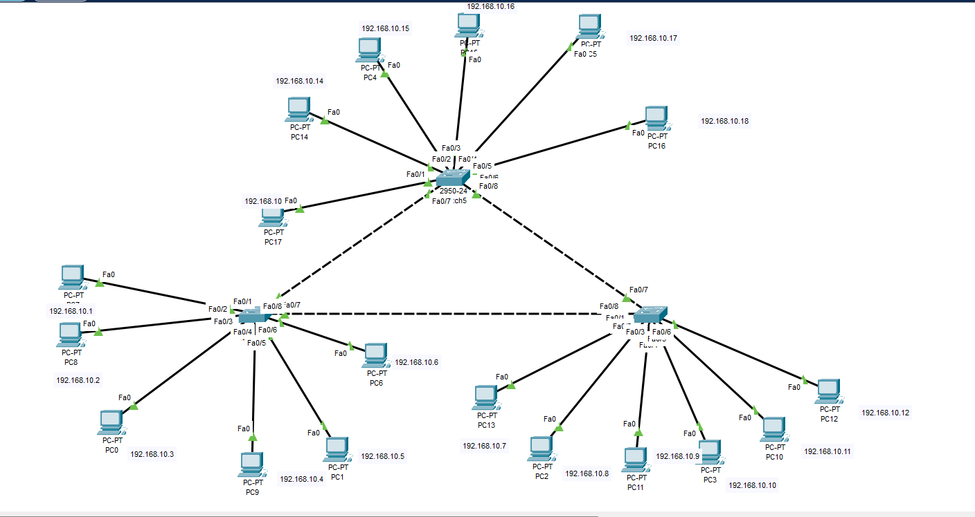

Step 2: - Make changes in environment of cisco packet tracer by going to preferences.

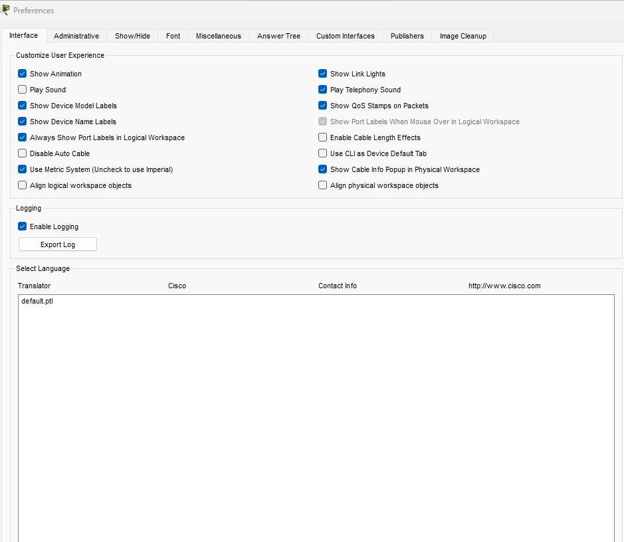

Step 3: - Configure all the switches using CLI command.

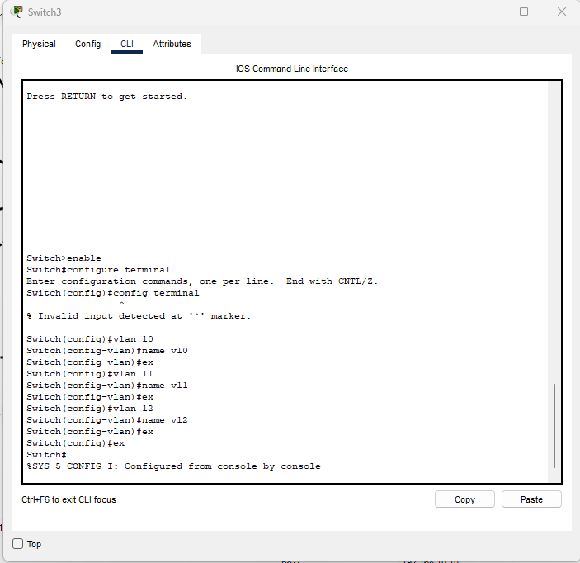

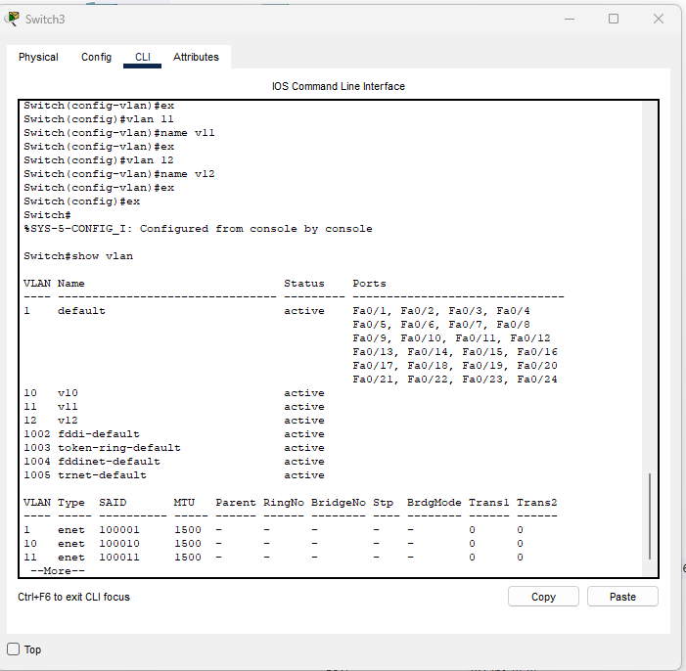

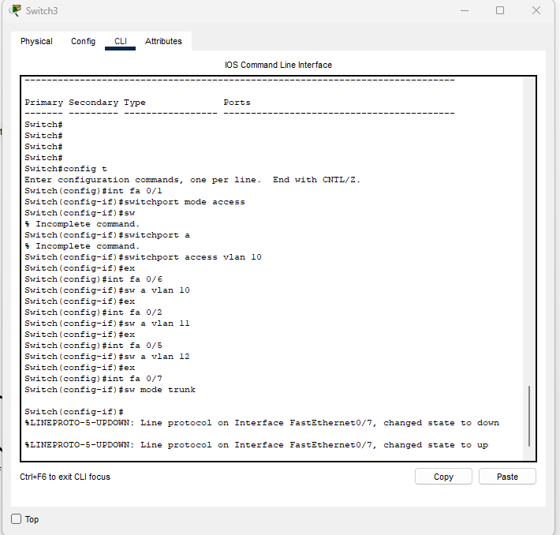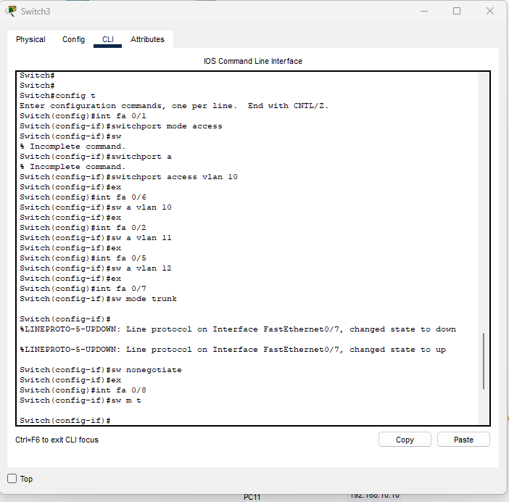

Step 4: - After configuring check for packet transferring

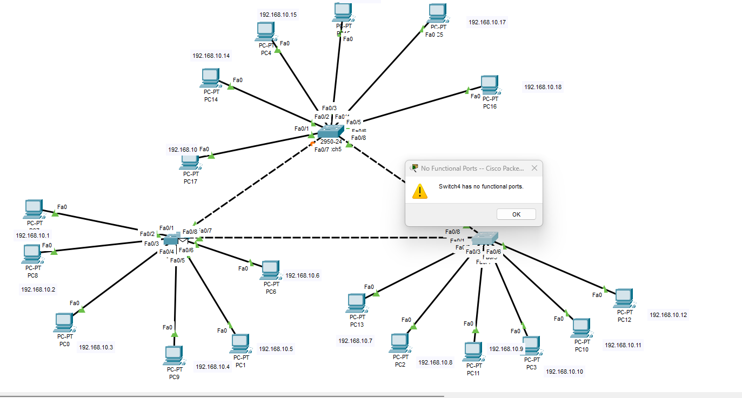

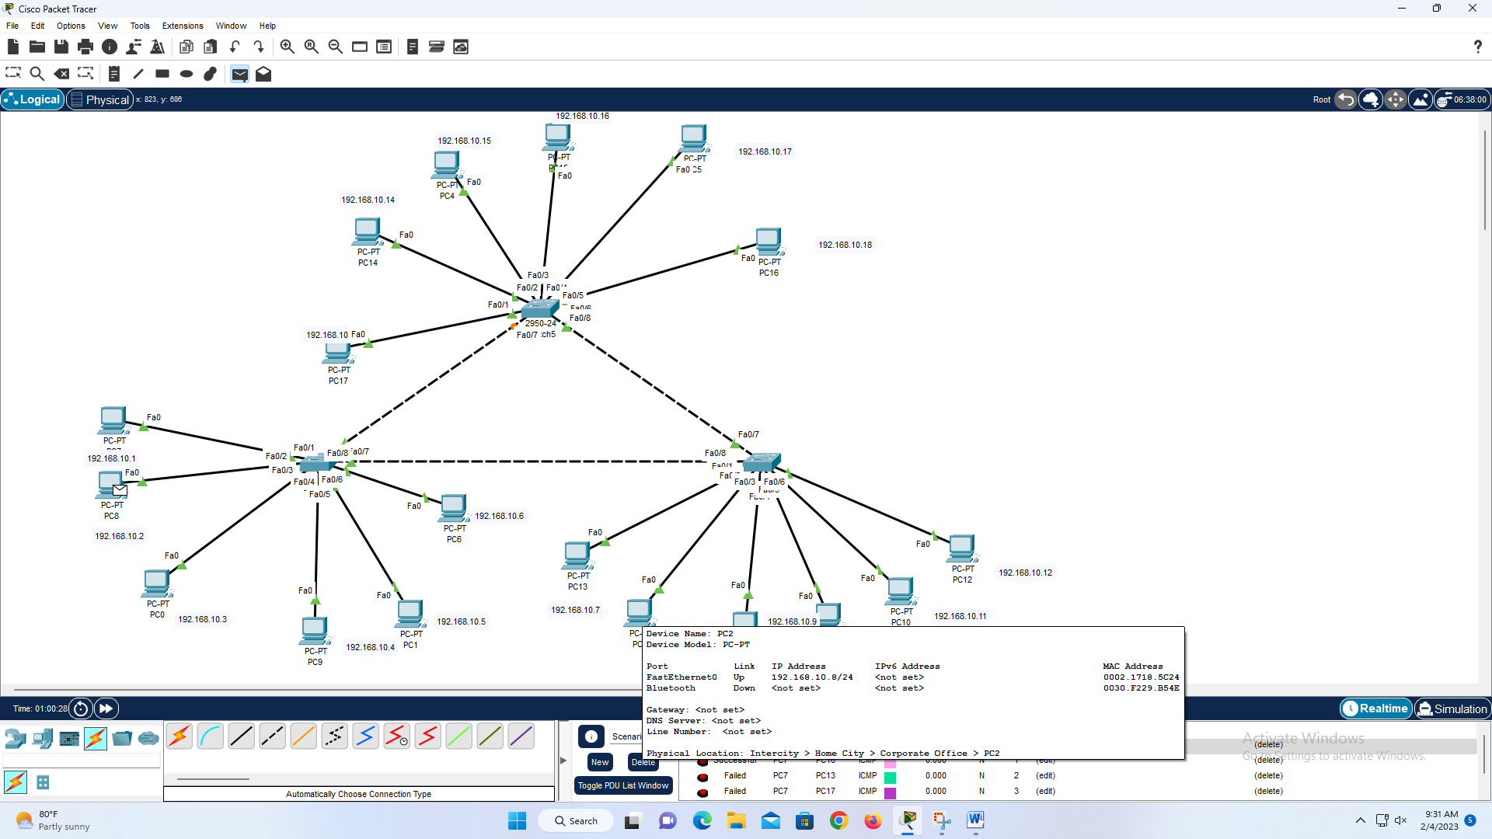

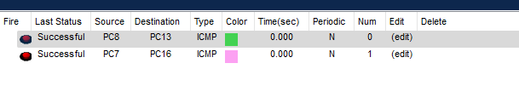

Result: -

Configuration of VLAN using Cisco Packet Tracer